**Practice Philosophy**

By: JJ Hoffstein

Contents

1 Introduction 8

1.1 Basic philosophy: skills & games 8

2 Advice for Assistant Coaches in Practice 8

2.1 Don’t be on your cell phone. 8

2.2 Work the room. 8

2.3 Don’t be on the same sideline as another coach. 8

2.4 Avoid small talk with other coaches. 9

2.5 Don’t talk while other coaches are talking. 9

2.6 Bring the “juice”. 9

2.7 Don’t be “unemployed”. 9

2.8 Carry an extra basketball. 9

2.9 Be one drill ahead of your head coach. 9

3 Practice Best Practices 9

3.1 “Animal Ball” rules 9

3.2 If you need to talk a lot, do it at the start of practice 9

3.3 Attack Dribbles Only 9

3.4 Pressure Free Throws 10

3.5 ATO Execution 10

4 Fun Warm-Up Drills 10

4.1 Layup Tic-Tac-Toe (@basket_ADN) 10

4.2 Half-Court Team Passing Competition (@basket_ADN) 11

4.3 “Grave” Cones (Comite Tecnic FCBQ) 12

4.4 Balloon Dribbling (@xavisastre5) 12

4.5 20 Passes in a Row (Boris Balibrea) 13

4.6 Full-Court 2v1 Passing (@basket_ADN) 14

4.7 Tennis Ball Dribbling 1v1 Competition (Tecnic TV) 14

4.8 Box Dribble Mirroring Game (Sergio Lopez) 14

4.9 1v3 into 3v5 Passing (@basket_ADN) 15

4.10 Monkey in the Middle (Tecnic TV) 15

4.11 Crossing the River (@basket_ADN) 16

4.12 4-Corners Change Drill (Allison McNeill) 17

5 Transition Offense/Defense Games 17

5.1 Alley 1v1 with Advantage Start (@Nick_Sciria) 17

5.2 Alley 2v2/3v3 with Advantage Start (@Nick_Sciria) 18

5.3 Pass Ahead 1v1 (@Nick_Sciria) 18

5.4 Pass Ahead 2v2/3v3 (@Nick_Sciria) 19

5.5 Sideways 2v2/3v3 (@train_ugly) 19

5.6 4v4 Mirror Drill Advantage, Two Possessions (@AlexJSarama) 19

5.7 5v5 Full Court Cone Transition (@r_b_j_c) 20

5.8 5v5 One/Two Runners (@JohnCarrier42) 20

5.9 5v5 Full Court Make It, Take It (@Nick_Sciria) 20

5.10 5v5 Arkansas Transition (@coachneighbors) 20

5.11 Full Court 5v5 + 8 Seconds or Less Double Bonus (@Nick_Sciria) 20

5.12 5v5 Transition Recovery, Four Trips (@Nick_Sciria) 21

5.13 Half court 5v5 with each possession beginning in a drag screen (@ Nick_Sciria) 21

5.14 Circle Transition (John Leonzo) 21

5.15 Full court 5v8 (Dave Smart) 21

6 Spacing Games 22

6.1 Wildcat 3v3/4v4 (@brianmccormick) 22

6.2 4v4 Canada Rules (@MackaymjMichael) 22

7 Screening/Cutting Games 22

7.1 3v2 Off-Ball Screening (@John Carrier42) 22

7.2 3v3 Baseball (@Nick_Sciria) 23

7.3 3v3/2v2/1v1 with Screening Start (@Topp33) 23

7.4 Kirby 3v3 (@Kirby_Schepp) 23

7.5 3v3/4v4 Cutting Advantage (@AlexJSarama) 23

7.6 3v3/4v4/5v5 Half Court Continuous with Attack the Basket Dribbles Only (@JohnCarrier42) 24

8 Skill Development / Advantage Offense 24

8.1 Shoulder to Chest Advantage 2v2/3v3/4v4/5v5 (@bballimmersion) 24

8.2 Time Pressure 2v2 25

8.3 Time Pressure 3,2,1 25

8.4 Blind Advantage 2v2/3v3/4v4/5v5 (@CoachHackGO) 25

8.5 Cone Touch Advantage 2v2/3v3/4v4/5v5 (@CoachHackGO) 25

8.6 Two Cones Advantage 2v2/3v3/4v4/5v5 (@CoachHackGO) 25

8.7 Three-Point Line Touch Advantage 2v2/3v3/4v4/5v5 (@bencfalk) 26

8.8 2v2 Sideways (Trevor Ragan) 26

8.9 2v2 Hornets (Trevor Ragan) 27

8.10 3v3 Triangle (Trevor Ragan) 28

8.11 4v4 Continuous (Trevor Ragan) 29

8.12 4v3 Drive Kick Kick (Trevor Ragan) 30

8.13 Advantage 1v1 30

8.14 Girl’s Game (Lynn Hersey) 31

8.15 Walk to Run Advantage 2v2/3v3/4v4/5v5 (@CoachHackGO) 31

8.16 Pass and Close Advantage 2v2/3v3/4v4/5v5 (@CoachHackGO) 31

8.17 Sideline Advantage 2v2/3v3/4v4/5v5 (@coachzhoops) 31

8.18 Dribble Around Advantage 2v2/3v3/4v4/5v5 (@Nick_Sciria) 32

8.19 Mirror Drill Advantage 2v2/3v3/4v4/5v5 (@Nick_Sciria) 32

8.20 2v2 Closeouts (@Nick_Sciria) 32

8.21 3v2 Shooting (@brianmccormick) 33

8.22 4v3 Shooting (@brianmccormick) 33

8.23 3v3/4v4/5v5 Continuous Half Court Transition (@Nick_Sciria) 33

8.24 Cone Touch Reaction (1v1/2v2/3v3) 34

8.25 3v3/4v4/5v5 Half Court Continuous Cone (@Nick_Sciria) 34

8.26 3v3/4v4 Half Court Continuous with 12-Second Shot Clock (@Nick_Sciria) 34

8.27 4v4/5v5 Half Court Chaos (@r_b_j_c) 34

8.28 Multitasking Concept (Alex Sarema) 35

8.29 1v1 Closeouts into Full Court (Claudio Cesar Prieto) 35

8.30 Toss 1v1 (@mshaughnessy11) 35

8.31 1v1 Self-Pass Contested Shooting (@tonywmiller) 36

8.32 1v1 Doghouse (Trevor Ragan) 36

8.33 Ace of the Court 37

8.34 Ultimate 1v1 (Trevor Ragan) 38

8.35 Alley 1v1 (@Nick_Sciria) 39

8.36 Help 1v1 (@PositionlessBb) 39

8.37 Help 1v2 (@PositionlessBb) 40

8.38 1v2 versus Pressure and Help (@BrandonHeyen_) 40

8.39 Transition 1v1 (@PositionlessBb) 41

8.40 Lane 1v1 (@JohnCarrier42) 41

8.41 Lane 1v1v1 (@Nicolas_Scira) 41

8.42 Chase Down 1v1 (@Nicolas_Scira) 41

8.43 1v1 Dribble to Half Then Attack (@basket_ADN) 43

8.44 Full Court 1v1 (@basket_ADN) 44

8.45 4v4 Line Advantage (@basket_ADN) 45

8.46 3v3 Track Race (@basket_ADN) 46

8.47 1v1 Full-Court Russell Westbrook Triangle (Gerald Hiller) 47

8.48 1v1 “Off the Hip” (Game Time Elite Training) 48

8.49 1v1 Sprinter’s Stance (@basket_ADN) 48

8.50 1v1 Handout (@basket_ADN) 48

8.51 3 Passes + Closeout (@basket_ADN) 49

8.52 3v3 w/ Advantage (@mshaughnessy11) 50

8.53 Random 1v1 (Sergio Lopez Sanchez) 51

8.54 2v2 Variations (Sergio Lopez) 52

8.55 1v1 “Cat & Mouse” (Gerard Hillier) 53

8.56 1v1 Perimeter Attack (Comite Tecnic FCBQ) 54

8.57 1v1 Touch Cone Attack (Gerard Hillier) 55

8.58 3v2 From a Closeout (Joventut de Badalona) 56

8.59 1v1 From a Closeout (@mshaughnessy11) 57

8.60 1v1 Inside/Out (Game Time Elite Training) 58

8.61 1v2 Basket Attack (Angel Tripiana) 59

8.62 1v1 Full Court Attack (@basket_ADN) 60

8.63 2v2 Basket Attack (Ziya Hepbir) 61

8.64 1v2 into 2v1 (@basket_ADN) 62

8.65 1v2 Advantage Finishing (@basket_ADN) 63

8.66 1v1 “Hot Potato” (@basket_ADN) 63

8.67 “Hot Potato” 2v1 (Adrian Murciano) 64

8.68 1v1 Who Receives Defends (@basket_ADN) 65

8.69 Five Plus One (Fran Francilla) 66

8.70 1v1 Interpret the Advantage (@basket_ADN) 67

8.71 1v1 Triangle Attack (Game Time Elite Training) 67

8.72 1v1 “Back-to-Back” (Comite Tecnic FCBQ) 68

8.73 “Blind Cut” 1v1 (Alex Sarama) 68

8.74 3v0 into 1v1 “One More” (Adrian Murciano) 69

8.75 1v1 “Fosters” (Cedarville WBB) 69

8.76 1v1 Cycle Pass (Eduardo Burgos) 70

8.77 1v1 Read & React Around Cones (@basket_ADN) 70

8.78 3v1 Double Pass (@basket_ADN) 71

8.79 1v1 Around Cones (@basket_ADN) 72

8.80 1v1 Chair Attack (@basket_ADN) 73

8.81 1v2 Receive & Attack (@basket_ADN) 74

8.82 2v2 Rugby (@brianmccormick) 74

8.83 Dribble Knockout (@Nick_Sciria) 75

8.84 4v3 (4) Passing Warmup 75

8.85 12-Second Drill (Xavier MBB) 75

8.86 Lane 1v1 for Ball Handling (@Nick_Sciria) 75

8.87 1v2/2v3 for Ball Handling/Passing against Traps (@Nick_Sciria) 75

8.88 4v5 Complete Ten Passes (David Richmond) 76

8.89 1v2/2v3 Ball Handling/Passing against Traps (@Nick_Sciria) 76

8.90 Gael 2v2/3v3/4v4/4v5/5v5 (@brianmccormick) 76

8.91 4v4/5v5 Ultimate Basketball (@Kirby_Schepp) 77

8.92 Six Spot Shooting (@Nick_Sciria) 77

8.93 Two Makes In A Row Shooting (@Nick_Sciria) 77

8.94 Two Misses In A Row Shooting (@Nick_Sciria) 77

8.95 Corner, Opposite Corner, Lift, Drift Shooting (@Gabe_MaciasGTET) 77

9 Shooting Games (No Defense) 78

9.1 3v3 Full-Court-Trios (@basket_ADN) 78

9.2 Full Court Diagonal (2 teams) (@basket_ADN) 79

9.3 Zach LaVine (Drew Hanlen) 79

9.4 Around the World (Drew Hanlen) 79

9.5 Moneyball Shooting (Drew Hanlen) 80

9.6 Louisville Shooting Challenge (@basket_ADN) 80

9.7 3-2-1 Perfect Drill (Chris Payne) 80

9.8 Olympic Shooting (Alex Sarama) 81

10 Overall Offense Games 81

10.1 “The Kinder Surprise” (Alex Sarama) 81

10.2 “Change” Drill (@fra_reds) 81

10.3 “Dagger” ORB 3v2 (@CoachZHoops) 81

10.4 6v6 No Dribble Zone O (Andrea Trinchieri) 82

10.5 5v5 Half Court/Full Court Perfect Offense (@Nick_Sciria) 82

10.6 3v3v3/4v4v4/5v5v5 Continuous Full Court (@Nick_Sciria) 82

10.7 Walsh 5v5 (@CoachBobWalsh) 82

10.8 5v5 with Any Start, Three/Four Trips (@r_b_j_c) 83

11 Overall Defense Games 83

11.1 Accountability Basketball 5v5 83

11.2 3v3v3/4v4v4/5v5v5 Full Court Football (@RadiusAthletics) 83

11.3 Kill Drill 83

11.4 3v3 Closeouts (Tony Bennett) 83

11.5 Decibel Level Game (Coach Yelich) 84

11.6 Defensive Bingo (Coach Yelich) 84

12 Situation-specific Games 84

12.1 Simulated shortened game 84

12.2 Timeout notecard tests 84

12.3 “Mind Bomb” Games 84

# Introduction

*You don’t ever rise to the occasion; you sink to your level of training. – Unknown*

The purpose of this document is to outline my practice philosophy so that I can communicate it to and iterate on it with players, coaches, administrators, colleagues, and friends. This document will also serve as a home-base for me to catalogue practice drills.

## Basic philosophy: skills & games

Basically, I believe that practice should be about learning skills, not learning drills. Learning new skills is one of the best things a player can do, whereas learning a drill will rarely translate into a live game setting. I think too many basketball coaches are more comfortable teaching drills than skills, which is a shame. Skills are extremely useful, whereas drills are usually useless.

At the same time, it’s critical that you practice like you play. Basketball is a competitive improvised game, not a friendly scripted game. A great practice will incorporate lots of competition and lots of opportunity for players to improvise. This is sometimes referred to as a “games approach” to coaching, and study after study has found the games approach to be more effective than other approaches because it maximizes (1) fun, (2) retention and transfer, (3) active learning time, and (4) conditioning. Therefore, a games approach is the best strategy for preparing your players to compete in games.

*If you purify the pond, the water lilies die. - Unknown*

# Advice for Assistant Coaches in Practice

Starting out as an assistant coach, I wish I had a little guidance as to how to maximize my value-add in practice. In this section, I will document tidbits of advice I have picked up for assistant coaches in practice (credit @coachliamflynn for many of these).

## Don’t be on your cell phone.

Before the first player walks in the gym, your phone should be away. Go and engage with players instead of being on social media.

## Work the room.

Physically walk around the gym instead of standing in one spot. Look for opportunities for personal coaching with the players. Look for opportunities to reinforce some of your head coach’s favorite cues.

## Don’t be on the same sideline as another coach.

Coaches should be standing in different physical locations in the gym. This will help maximize the teaching output of the entire coaching staff.

## Avoid small talk with other coaches.

The focus should always be on the players and the practice mission. Socializing and small talk can wait until after practice.

## Don’t talk while other coaches are talking.

Set a good example for the players and pay attention to other coaches as if you have something to learn (because you probably do).

## Bring the “juice”.

No one is going to tell you to bring the “juice”, it’s up to you to bring it every day. Be energetic, passionate, and enthusiastic. You’re in a basketball gym, for goodness sakes.

## Don’t be “unemployed”.

Always look for work in practice. Re-rack basketballs, re-set the clock, pick-up towels. Make yourself useful.

## Carry an extra basketball.

Be ready to throw a basketball back into a drill if one flies away. This will help keep practice more efficient.

## Be one drill ahead of your head coach.

This will help minimize the transition time between drills.

# Practice Best Practices

Here are some “best practices” to consider for your practices:

## “Animal Ball” rules

Animal ball means you don’t have to take the ball out of bounds after a made basket or a dead ball. This will help keep practices high-paced and eliminate dead time.

## If you need to talk a lot, do it at the start of practice

You don’t want to have to stop practice to talk a lot or walk through something. Rather than players getting cold like that, do your talking session at the start of practice.

## Attack Dribbles Only

We used to play 5v5 with no dribbles a lot, but @BBallImmersion helped me realize that there was a smarter approach out there.

I now prefer "attack dribbles only," a better way to simulate the closeout decisions and advantage scenarios that occur within our style of offense

## Pressure Free Throws

It’s tempting to skip FT shooting when players draw shooting fouls in drills, but that is actually the best time to practice FT shooting with the pressure on. Shooting 1 free throw for all the marbles is a good way to split the difference.

## ATO Execution

Very cool idea from @CoachSutton re improving execution of ATOs. Between drills have each team play 1 possession - SOOBs, EOOBs, in court - practicing your ATOs (or 2 for 1s). Better than having 10- 20mins of one possession games where it’s too stop/start and players get cold.

# Fun Warm-Up Drills

Here are some fun, not-really-basketball drills to warm-up with:

## Layup Tic-Tac-Toe (@basket_ADN)

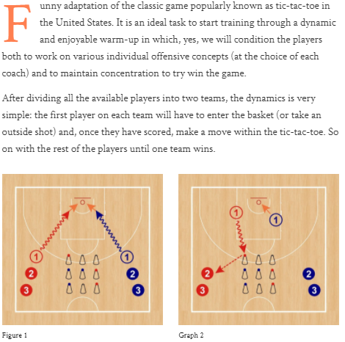

## Half-Court Team Passing Competition (@basket_ADN)

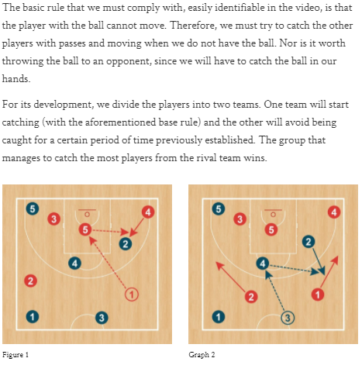

## “Grave” Cones (Comite Tecnic FCBQ)

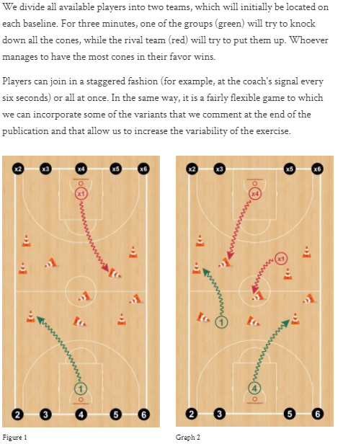

## Balloon Dribbling (@xavisastre5)

Dribble while keeping balloon in air, w/ lots of variations

## 20 Passes in a Row (Boris Balibrea)

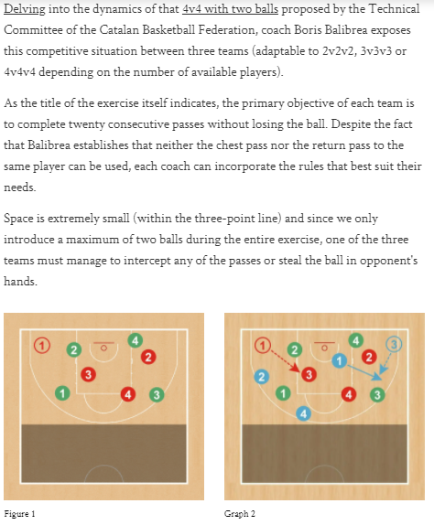

## Full-Court 2v1 Passing (@basket_ADN)

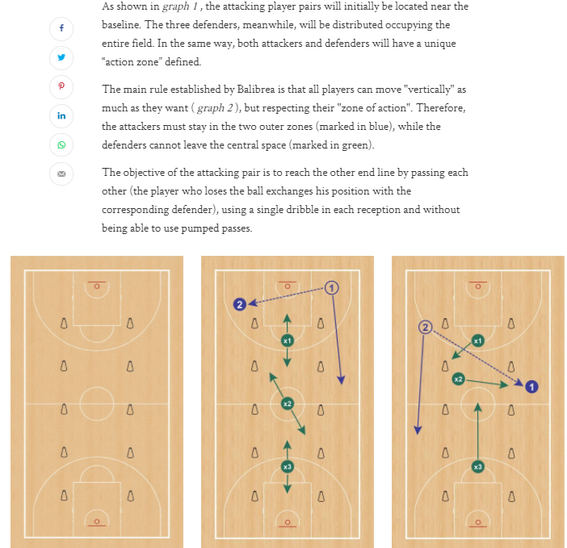

## Tennis Ball Dribbling 1v1 Competition (Tecnic TV)

https://www.youtube.com/watch?v=H2aFLTl84e0

## Box Dribble Mirroring Game (Sergio Lopez)

https://www.youtube.com/watch?v=MTb83HJDYWw

## 1v3 into 3v5 Passing (@basket_ADN)

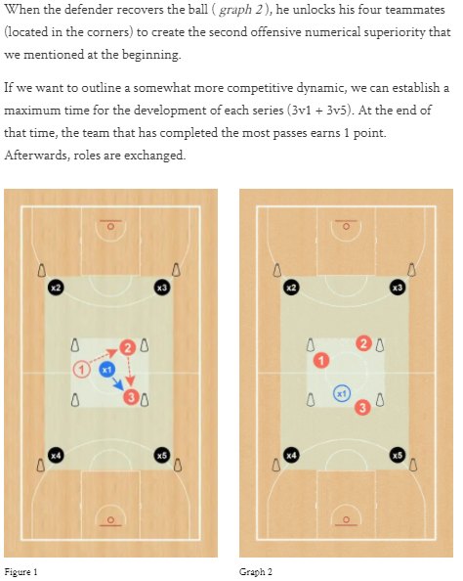

## Monkey in the Middle (Tecnic TV)

https://www.youtube.com/watch?v=F9Aq1Mr8g_0

## Crossing the River (@basket_ADN)

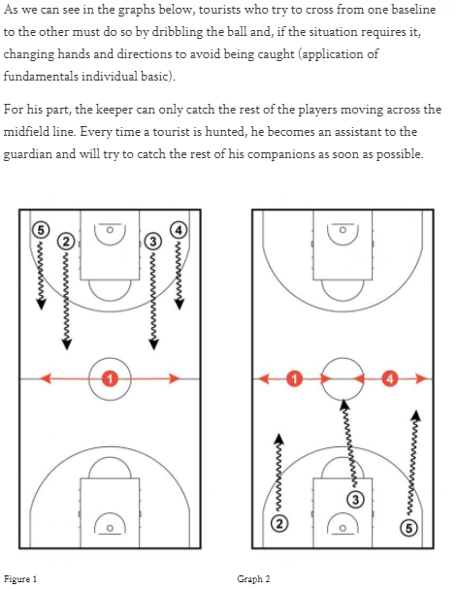

## 4-Corners Change Drill (Allison McNeill)

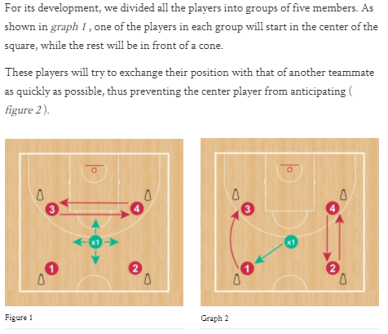

<https://youtu.be/uMnakWTRvOE>

Progression: add dribbling -

https://www.youtube.com/watch?v=R0J5PL9ZiXA

# Transition Offense/Defense Games

Here are some games that specifically work on transition offense and defense:

## Alley 1v1 with Advantage Start (@Nick_Sciria)

1’s and 2’s to 5

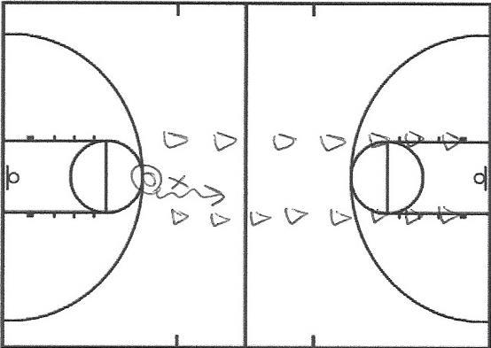

https://twitter.com/Nick_Sciria/status/1132061485616836609

## Alley 2v2/3v3 with Advantage Start (@Nick_Sciria)

1’s, 2’s and 3’s to 10

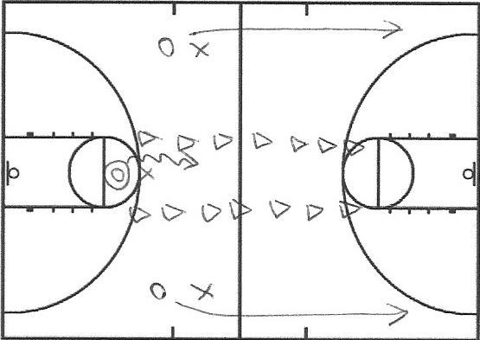

* Ballhandler must get a paint touch before passing

## Pass Ahead 1v1 (@Nick_Sciria)

1’s and 2’s to 5

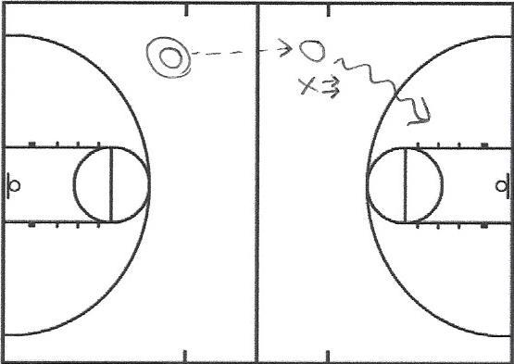

* The ballhandler passes ahead to the off-ball wing (who is looking over his shoulder for the ball and is allowed to start running on the release of the pass). The on-ball defender (facing the hoop, not the ball) is not allowed to start running until they see the ball.

## Pass Ahead 2v2/3v3 (@Nick_Sciria)

1’s, 2’s and 3’s to 10

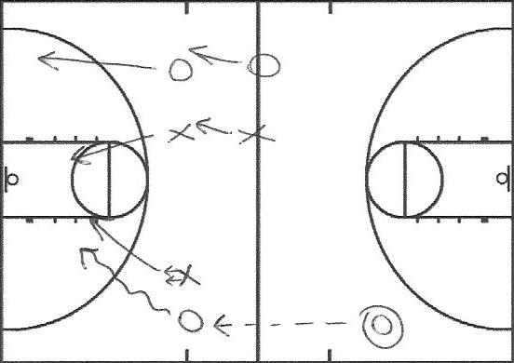

The ballhandler passes ahead to the off-ball wing (who is looking over his shoulder for the ball and is allowed to start running on the release of the pass). The on-ball defender (facing the hoop, not the ball) is not allowed to start running until they see the ball. The weak-side defenders are allowed to begin running when the pass is released.

## Sideways 2v2/3v3 (@train_ugly)

1’s and 2’s to 5

This is a “full court” make it, take it game played on a main hoop and a side hoop instead. On a made basket, the offense stays on offense and goes the other way (baskets switch). The defense is not allowed to touch the ball after a make (they are still on defense). Players may pass or dribble the ball out of the net after a make (no inbounds). There is no out of bounds.

https://www.youtube.com/watch?v=b-d5deTnqtA

## 4v4 Mirror Drill Advantage, Two Possessions (@AlexJSarama)

1’s, 2’s and 3’s to 10

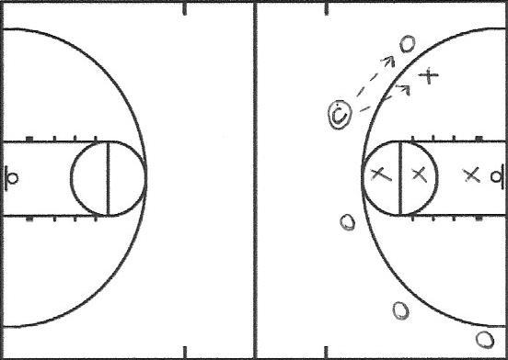

Players on the strong side circle the three-point line doing mirror drill (the offensive player tries to get separation from the defensive player). The coach can pass to either player. If the coach passes to the offensive player, play at that hoop and then down. If the coach passes to the defensive player (simulating a turnover situation), play down and back.

## 5v5 Full Court Cone Transition (@r_b_j_c)

1’s, 2’s and 3’s to 10

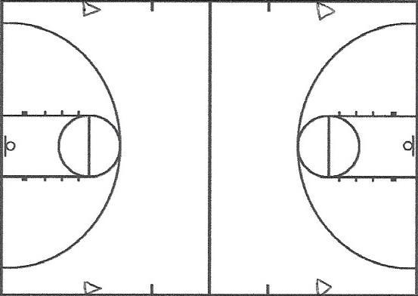

The last player to touch the ball on every offensive possession (shot/turnover) must run around one of the cones on that side of the court before running back on defense.

## 5v5 One/Two Runners (@JohnCarrier42)

1’s, 2’s and 3’s to 10

Each team has one/two designated runners. On a change of possession from offense to defense, the designated runner(s) must touch the baseline before getting back on defense.

## 5v5 Full Court Make It, Take It (@Nick_Sciria)

1’s, 2’s and 3’s to 10

On a made basket, the offense stays on offense, inbounds the ball and goes the other way (baskets switch). The defense is not allowed to touch the ball after a make (they are still on defense).

## 5v5 Arkansas Transition (@coachneighbors)

Play a full-court game with a 30-second shot clock (resets on change of possessions and offensive rebounds). The point value of each shot is determined by how much time is remaining on the shot clock. If a player is fouled, they shoot one free throw worth the amount of points that are left on the shot clock. Play to 100.

https://www.youtube.com/watch?v=lGI40sE6afs

## Full Court 5v5 + 8 Seconds or Less Double Bonus (@Nick_Sciria)

1’s, 2’s and 3’s to 15

If a team scores in the first eight seconds of a possession, they receive double the points.

## 5v5 Transition Recovery, Four Trips (@Nick_Sciria)

1’s, 2’s and 3’s to 10

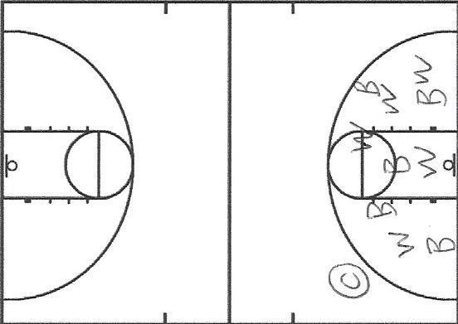

The players randomly jog around inside the three-point line. The coach passes the ball to any player and transition play begins going towards the other hoop. One (or two defenders) must touch the baseline before running back on defense.

Examples: Any defender, whoever the coach names, whoever is farthest away from the ball, whoever is closest to the ball (working on communication) etc.

## Half court 5v5 with each possession beginning in a drag screen (@ Nick_Sciria)

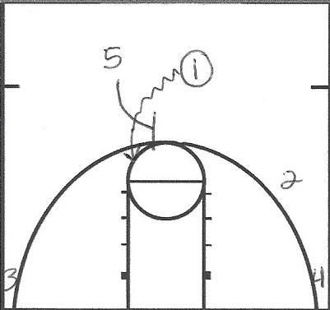

## Circle Transition (John Leonzo)

Run in a circle, coach deliver the ball, and transition the other way. A lot better than line transition.

https://twitter.com/coachzhoops/status/1159157492888363010

## Full court 5v8 (Dave Smart)

Three offensive players are at half-court on the sidelines, rotate in automatically with three other pre-designated offensive players. Five defenders have to sprint back in transition D to cover these pre-designated leakers.

# Spacing Games

Here are some games that emphasize court spacing:

## Wildcat 3v3/4v4 (@brianmccormick)

1’s, 2’s and 3’s to 10

Play a half-court game of 3v3 or 4v4 with one constraint (all offensive players must catch the ball outside of the three-point line or on a direct basket cut to the rim).

https://www.youtube.com/watch?v=juU8hHraJ2Y

## 4v4 Canada Rules (@MackaymjMichael)

1’s, 2’s and 3’s to 10

Half court 4v4 with the constraint being that there can’t be two guys in the same box at any point in a possession (or it’s a turnover).

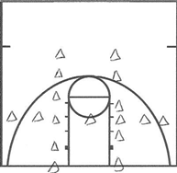

https://youtu.be/9ndhYdT2RV0

# Screening/Cutting Games

Here are some games that specifically work on screening and cutting:

## 3v2 Off-Ball Screening (@John Carrier42)

1’s, 2’s and 3’s to 10

The offense has a passer, a screener and a first cutter. The first cutter has five seconds to use screens and get open to score. Once they catch the ball, he/she plays the defender 1v1 (three dribble limit). If the on-ball defender gets a deflection, it is one point.

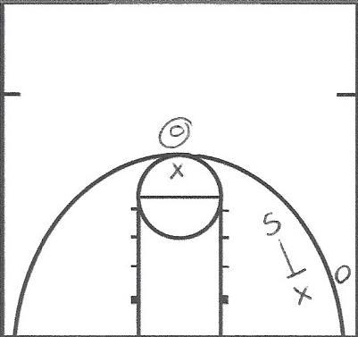

## 3v3 Baseball (@Nick_Sciria)

1’s, 2’s and 3’s

Play a half-court game of 3v3. Every inning lasts two minutes and denotes a different action the offense must use to create an advantage/score (examples: ball screens, back screens, down screens, dribble handoffs etc)

## 3v3/2v2/1v1 with Screening Start (@Topp33)

1’s, 2’s and 3’s to 10

The offense has a designated passer (or coach) for the possession. The offense begins with a screening action and the passer puts the first ball into play by passing to an open player. The 3v3 game continues until a player. On the first shot (or turnover), that offensive player is out (along with the player who was defending him/her). The passer then throws another ball in and play continues in a 2v2 format. The next player who shoots is off along with the player who was defending him/her. The passer throws the last ball in and play continues in a 1v1 format. Then switch offense/defense.

https://twitter.com/Nick_Sciria/status/1153478165320388608

## Kirby 3v3 (@Kirby_Schepp)

1’s, 2’s and 3’s to 15

Play a half-court game of 3v3. One player from each team is not allowed to dribble and his/her points are worth double (players should actively try to get this player open). Made shots for the other two players on the team are worth only one. The designated player changes every time he/she scores (rotate through each member on the team).

## 3v3/4v4 Cutting Advantage (@AlexJSarama)

1’s, 2’s and 3’s to 10

The offensive player passes to his teammate in the corner and cuts to the basket (either way). The defender guarding the cutter starts facing the hoop and isn’t allowed to move until they see the ball in flight. The offensive player in then decides whether to pass it back to the cutter or skip it to the weak side based on the help defender. You can also have the help defender run around a cone on the weak side so they aren’t stationary.

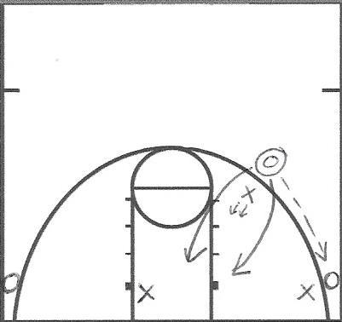

## 3v3/4v4/5v5 Half Court Continuous with Attack the Basket Dribbles Only (@JohnCarrier42)

1’s, 2’s and 3’s to 10

Play a half court game of 3v3/4v4/5v5. Players are only allowed to dribble if they are attacking the basket (that means they can’t dribble to take the ball back behind the three-point line).

https://www.youtube.com/watch?v=3NpinhDmpoU

# Skill Development / Advantage Offense

Here are some general “advantage offense” and skill development games:

Notes:

* Advantage games can be three trips (here, down and back), one score and switch (take it back on change of possessions), one score and switch (don’t need to take it back on change of possessions) or one offensive possession and switch.
* Advantage games can be played with offensive players and defensive players anywhere on the court to start (depending on your offense and what you want to focus on).
* You can also play advantage games with more players on offense than on defense (just add a passing maximum). For example—in advantage 3v2, the offense may be limited to two passes (a kickout pass and a one more pass).

## Shoulder to Chest Advantage 2v2/3v3/4v4/5v5 (@bballimmersion)

1’s, 2’s and 3’s to 10

The defensive player starts with his/her chest in line with offensive player’s shoulder. The offensive player takes one, two, three, four or five dribbles to begin the play. Both players are stationary until the offensive player begins driving.

## Time Pressure 2v2

We are playing 2on2 either with a DHO or Throw & Go (Pistol). There is a 5 second countdown, countdown starts on either the first dribble or airtime of pass. Play 1 shot, must stay on side of court. ADDING third option-Pass to coach pindown/flare.

## Time Pressure 3,2,1

3-2-1: 3v3 game, shooter goes off, then 2v2, shooter goes off, then 1v1, countdown from 5...4...3...2...1

## Blind Advantage 2v2/3v3/4v4/5v5 (@CoachHackGO)

1’s, 2’s and 3’s to 10

The offensive player starts with the ball on the defender’s back for at least one second. When he takes the ball off the defender’s back and begins driving, play is live. The offensive player is not allowed to fake which way he is going.

## Cone Touch Advantage 2v2/3v3/4v4/5v5 (@CoachHackGO)

1’s, 2’s and 3’s to 10

The defensive player flips the ball to the offensive player and must touch one of the cones before recovering.

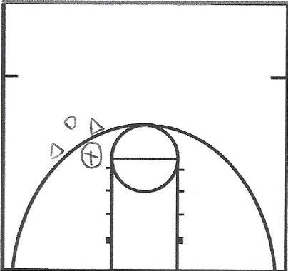

## Two Cones Advantage 2v2/3v3/4v4/5v5 (@CoachHackGO)

1’s, 2’s and 3’s to 10

Offensive player starts behind the baseline with the defender a few feet behind him. When the offensive player begins dribbling, the defensive player can begin running. For a big advantage, have the offensive player dribble around the first cone while the defense runs around the second cone. For a smaller advantage, have the offensive player dribble around the second cone while the defense runs around the first cone.

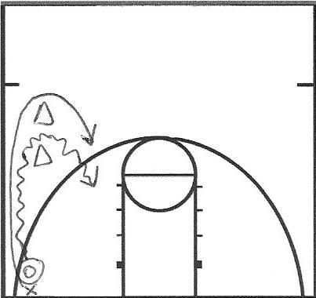 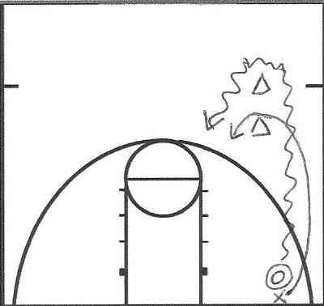

## Three-Point Line Touch Advantage 2v2/3v3/4v4/5v5 (@bencfalk)

1’s, 2’s and 3’s to 10

The ball is swung to the offensive player. The defensive player starts a few feet away from the three-point line and must touch the line (with one or both feet, depending on how big of an advantage you want) before defending the drive.

## 2v2 Sideways (Trevor Ragan)

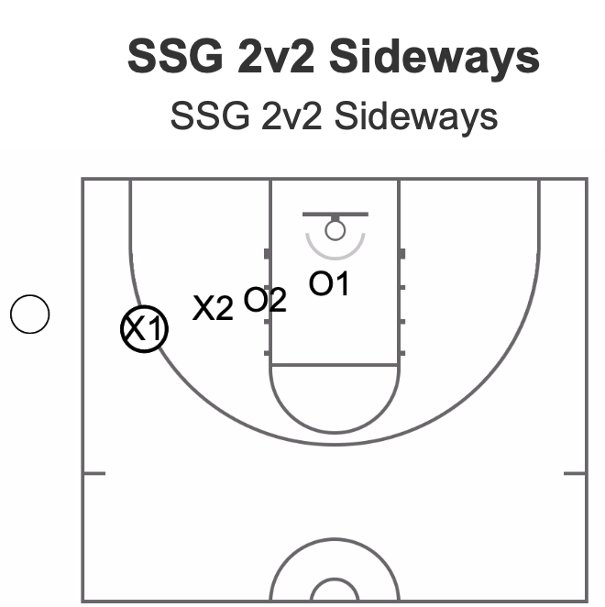

* Regular 2v2 between the main goal and the side goal beginning with a jump-ball
* Team that wins the tip can score on any goal first and that establishes the goals for that 60-second segment.
* 2 points for layups / 1 point for jump shots
* Foul = point value for shot and change of possession quickly
* Play for 60 seconds and switch teams
* Can play as a running score or each game separately.

## 2v2 Hornets (Trevor Ragan)

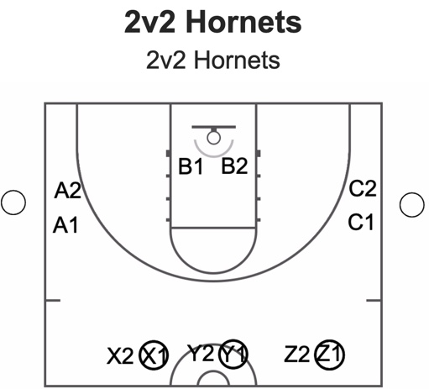

* Six separate teams of two; Three teams start on offense and three on defense
* Offensive teams can score on any basket and must call their score on each make
* Defensive teams can only defend at their basket
* Defense can become offense if they secure a ball in their area (missed shot rebound, steal, etc.)
* If an offensive team loses their ball to a defensive team, they replace them at that goal as the new defensive team
* Offense can switch attacking goals at any time and two or more teams can attack the same goal at any time

## 3v3 Triangle (Trevor Ragan)

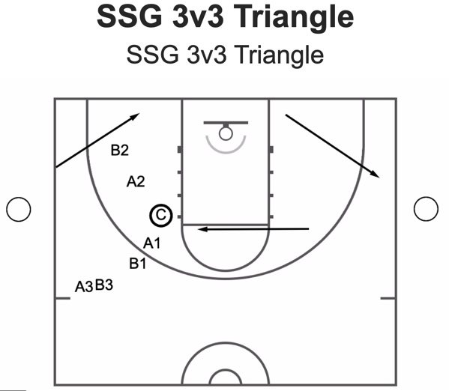

* 3v3; Coach shoot the ball to begin the drill
* Team that rebounds it gets to start on offense at the goal that was just shot on
* Make = Keep possession
* Defensive rebound = moving to the next goal
* Offensive rebound =. Keep playing at that goal

**Variation:**

* Switch direction
* Play all seven goals
* Make = whoever gets the ball gets to keep it

## 4v4 Continuous (Trevor Ragan)

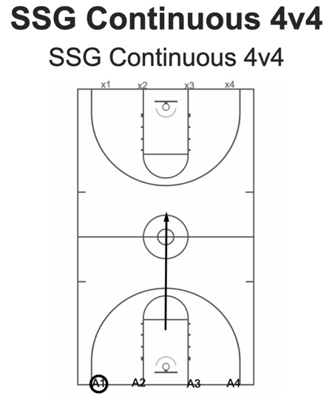

* Basketball rules apply (scoring, OB, fouls, etc.)
* ***A*** team attacks X team
* If ***A*** scores, the next X team/subs take the ball out and immediately push in transition
* If X gets a stop, they stay on and push in transition
* In other words: If you get scored on, you’re team is off or your subs come in
* Playing by quarters can allow teams to strategize, communicate, and set their sub patterns
* *Shot clock, cut-throat style, steals/deflections, call the score, celebration.

## 4v3 Drive Kick Kick (Trevor Ragan)

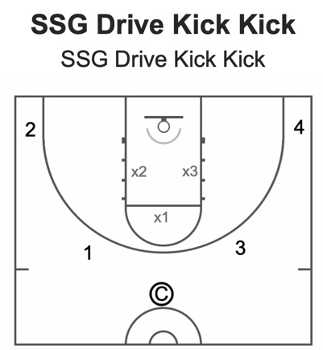

* Coach starts by throwing the ball to any of the four perimeter offensive players
* Offensive is searching for “drive-kick-kick” three point shots or layups
* Defense gets a point for a stop
* Offensive gets their point value for the shot they make
* *Turnovers = +2 for defense

## Advantage 1v1

1’s and 2’s to 10

* Shoulder to Chest (https://twitter.com/Nick_Sciria/status/1151268725351419904)
* Blind (https://youtu.be/LE7cmo8bRko?t=9)
* Cone Touch (https://youtu.be/LE7cmo8bRko?t=79)
* Two Cones (https://twitter.com/Nick_Sciria/status/1151268725351419904)
* Three-Point Line Touch
* Walk to Run (https://youtu.be/LE7cmo8bRko?t=25)
* Pass and Close (https://youtu.be/LE7cmo8bRko?t=43)
* Sideline (https://twitter.com/coachzhoops/status/1006361087380480000)
* Dribble Around
* Mirror Drill (https://twitter.com/Nick_Sciria/status/1153417512392044549)

## Girl’s Game (Lynn Hersey)

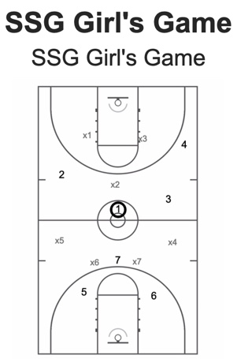

* Begins with jump-ball
* Team that gains control is playing 4v3
* On a miss or make, change possessions.
* The players can only stay on the side of the court they start on (always +1 offense)
* Hunting 3’s and layups
* Timed quarters-mini game.

## Walk to Run Advantage 2v2/3v3/4v4/5v5 (@CoachHackGO)

1’s, 2’s and 3’s to 10

Offensive and defensive player start walking next to each other (shoulder to shoulder) with the offensive player dribbling the ball. When the offensive player begins driving, play is live.

## Pass and Close Advantage 2v2/3v3/4v4/5v5 (@CoachHackGO)

1’s, 2’s and 3’s to 10

The defensive player starts inside the lane, passes the ball out to the offensive player and closes out.

## Sideline Advantage 2v2/3v3/4v4/5v5 (@coachzhoops)

1’s, 2’s and 3’s to 10

See set up diagrammed below. When the offensive player begins dribbling, the defensive player can begin running.

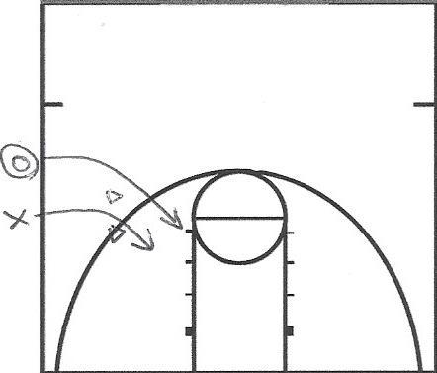

## Dribble Around Advantage 2v2/3v3/4v4/5v5 (@Nick_Sciria)

1’s, 2’s and 3’s to 10

See set up diagrammed below. Offensive player must take two dribbles behind the three-point line. The defender can begin moving after the offensive player’s second dribble.

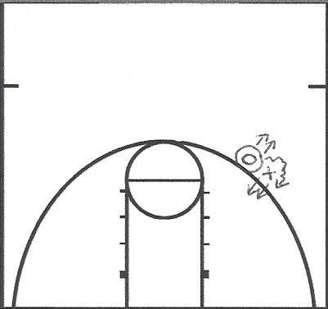

## Mirror Drill Advantage 2v2/3v3/4v4/5v5 (@Nick_Sciria)

1’s, 2’s and 3’s to 10

Players on the strong side circle the three-point line doing mirror drill (the offensive player tries to get separation from the defensive player). When the coach throws the ball to the offensive player, he/she drives and play is live.

## 2v2 Closeouts (@Nick_Sciria)

1’s, 2’s and 3’s to 10

The ball handler begins with a shoulder to chest advantage. The help defender can begin running around the cone when the ball handler begins to drive (needs both feet around the cone). The ball handler needs to get a paint touch before passing and the player guarding him/her tries to get a deflection (worth one point). The shooter starts in line with the help defender but can move and catch the ball anywhere behind the three-point line and below the cones. If the shooter decides to drive, it is 1v1.

Modification Possibilities: Length of closeout (how close to the rim line the cone is), angle of closeout (how close to the baseline/arc the cone is), starting location of the shooter (and where he/she is allowed to catch it) and angle/location of the initial drive.

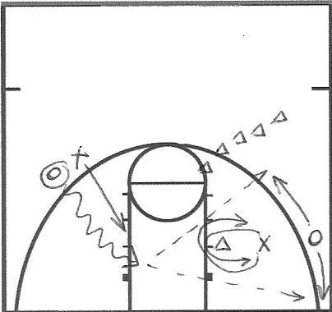

https://twitter.com/Nick_Sciria/status/1131701918793908226

## 3v2 Shooting (@brianmccormick)

1’s, 2’s and 3’s to 10

Play one half-court possession (one shot). The team on offense gets a one player advantage and can pass a maximum of three times before shooting. Players can only catch the ball behind the three-point line (but are allowed to drive).

If you want to add offensive rebounding, you can make a rule that the player to get the offensive rebound must kick it out behind the three-point line and play continues with the offensive rebounder stepping off (2v2). You can also make a rule that the shooter isn’t allowed to rebound a miss (so they step off and the others play 2v2 with unlimited passes until there is a stop/score).

## 4v3 Shooting (@brianmccormick)

1’s, 2’s and 3’s to 10

Play one half-court possession (one shot). The team on offense gets a one player advantage and can pass a maximum of three times before shooting. Players can catch the ball inside the three-point line (cut) or drive.

If you want to add offensive rebounding, you can make a rule that the player to get the offensive rebound must kick it out behind the three-point line and play continues with the offensive rebounder stepping off (3v3). You can also make a rule that the shooter isn’t allowed to rebound a miss (so they step off and the others play 3v3 with unlimited passes until there is a stop/score).

https://www.youtube.com/watch?v=CNOYzsfEJL8

## 3v3/4v4/5v5 Continuous Half Court Transition (@Nick_Sciria)

1’s, 2’s and 3’s to 15

Play a 3v3/4v4 half-court game. On any change of possession, the new offense passes the ball to the coach and he/she immediately puts the ball back into play (by passing to any offensive player outside the three-point line). Meanwhile, all the players on the new defense must get two feet inside the paint (does not need to be simultaneous) before playing defense.

## Cone Touch Reaction (1v1/2v2/3v3)

* X1 starts the drill by touching outside either cone, O1 reacts & attacks the open space, X1 then turns & contests.
* 2v2 Reaction Pen & Kick/Finish (clip 1): X1 starts by stepping across & touching outside the cone, O1 drives and must read the help D, drive or kick
* 3v3 Reaction Pen & Kick/Finish (clip 2): Same as above however X1 can now send O1 left or right.

## 3v3/4v4/5v5 Half Court Continuous Cone (@Nick_Sciria)

1’s, 2’s and 3’s to 15

The last player to touch the ball on every offensive possession (shot/turnover) must run around one of the cones before playing defense. The new offense must take the ball back behind the three-point line every time (while the other defenders are live). The cones in the paint in the diagrams below are actually behind the baseline.

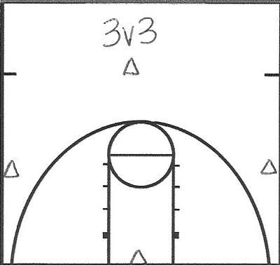 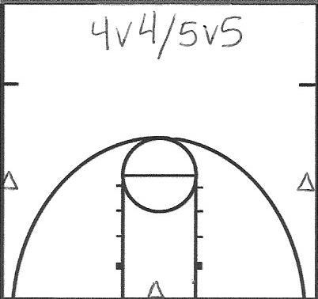

https://twitter.com/Nick_Sciria/status/1095120167770689537

## 3v3/4v4 Half Court Continuous with 12-Second Shot Clock (@Nick_Sciria)

1’s, 2’s and 3’s to 10

No checks (take everything back behind the three-point line). Shot clock resets every time the ball hits the rim.

https://www.youtube.com/watch?v=5UPv2qtezf8

## 4v4/5v5 Half Court Chaos (@r_b_j_c)

1’s, 2’s and 3’s

Offense stays on offense for one minute and tries to score as many points as possible. On a shot/turnover, the defense throws the ball to a coach (who puts a new ball into play by passing to any offensive player behind the three-point line).

## Multitasking Concept (Alex Sarema)

Experimenting with Different multitasking games 🧠 today during the ball handling warmup: mathematics 🧮 , quick personal info questions ❓, vision “can you see what I see” 👀 and the last load physical: pushing and pulling.

## 1v1 Closeouts into Full Court (Claudio Cesar Prieto)

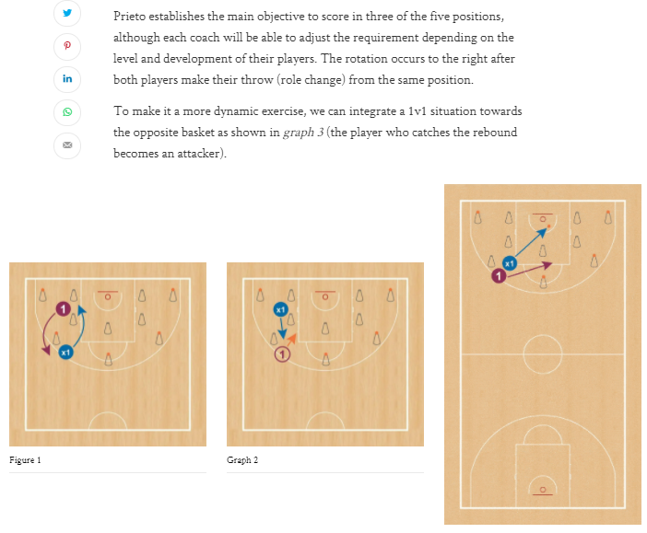

## Toss 1v1 (@mshaughnessy11)

Offense & defense pass back & forth as they slowly travel around the 3pt line together

• Quick decision - Shoot or attack closeout

• Make shots versus late contest

• Finish driving through contact

Defense is reacting to when offensive player makes a decision.

## 1v1 Self-Pass Contested Shooting (@tonywmiller)

Offense: self-pass 🡪 shot

Defense: tag a cone on the self-pass 🡪 contest

Can move locations / cones all around the floor

## 1v1 Doghouse (Trevor Ragan)

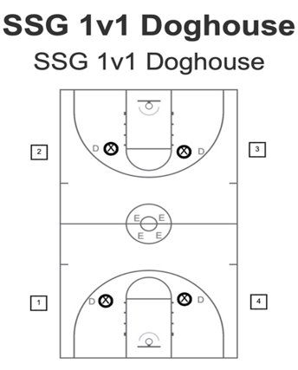

* Any defender who gets scored on goes to the dog house. A player from the dog house replaces them as a new defender.
* If a defender gets a stop, they become the offensive player and the offensive player becomes the defender.

## Ace of the Court

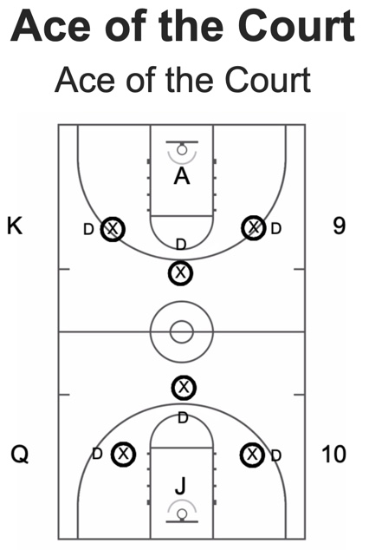

* Each player draws a card at the beginning of practice to determine where they start
* King of the Court rules
* If the offensive player scores, the defense gets a chance to match. No match = move down a court
* Goal is to be the ace court

## Ultimate 1v1 (Trevor Ragan)

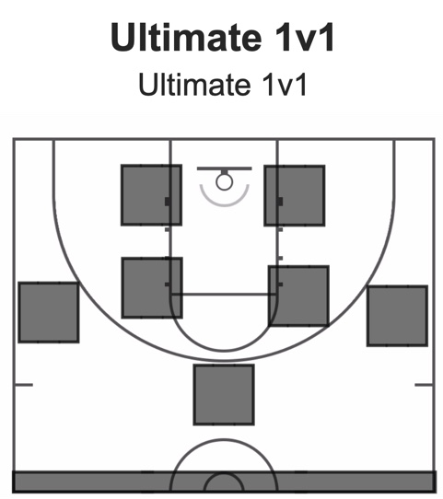

* Offense self-tosses to begin each possession
* Each player gets 3-5 offensive possessions each (each made basket is worth 1)
* At the end of their possessions, they shoot two free throws (or a 1 and 1) for a chance to add on to their score
* Most points at the end is the winner

## Alley 1v1 (@Nick_Sciria)

1’s and 2’s to 5

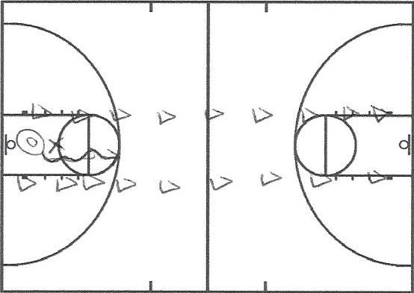

Elbow 1v1 (@PositionlessBb): 1’s and 2’s to 5

Cones can be placed at any location on the court. In this game (and many of the games in this section), the offense can start whenever they want (no faking). On first movement, the defender(s) begins running and the game is live.

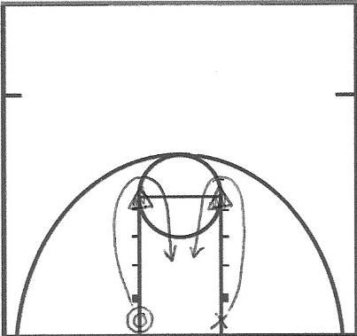

## Help 1v1 (@PositionlessBb)

1’s and 2’s to 5

The coach passes to the offensive player (or player spins it to him/herself). The offensive player catches and uses a momentum rip through to drive (can also use other moves). When the ball is caught, the defender must get two feet outside the lane before contesting the shot.

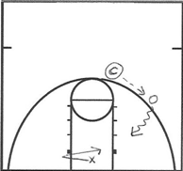

## Help 1v2 (@PositionlessBb)

1’s and 2’s to 5

Play begins on the first movement of the offensive player.

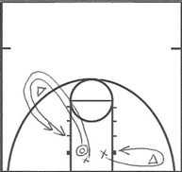

## 1v2 versus Pressure and Help (@BrandonHeyen_)

1’s and 2’s to 5

The on-ball defender and ball handler start a few feet behind the three-point line. The on-ball defender pressures the ball (trying to steal it) until the ball handler gets inside the three-point line. Once inside the three-point line, the help defender (who starts outside the lane) is live as the ball handler drives to the basket.

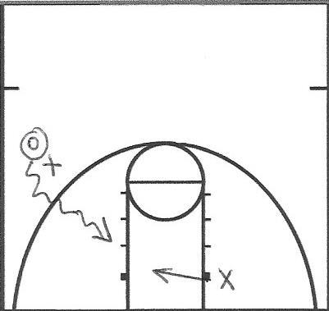

https://twitter.com/brandonheyen_/status/1143955841797840897?s=21

## Transition 1v1 (@PositionlessBb)

1’s and 2’s to 5

The defender passes ahead to the offensive player and runs to the rim as the offensive player drives.

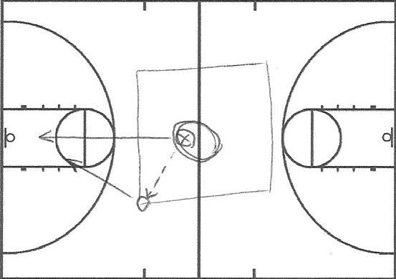

## Lane 1v1 (@JohnCarrier42)

1’s and 2’s to 5

The offensive player can only score in the shaded area. The lane lines are out of bounds. Reset after every shot.

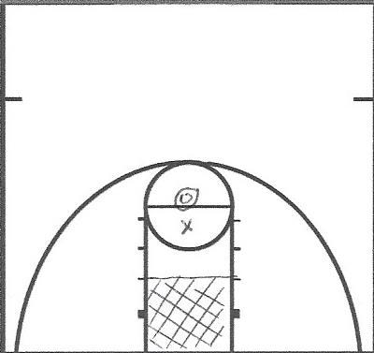

## Lane 1v1v1 (@Nicolas_Scira)

1’s and 2’s to 5

The ball is always live (even on makes—anyone can rebound it) and there is no out of bounds. Players must score inside the lane.

## Chase Down 1v1 (@Nicolas_Scira)

1’s and 2’s to 5

Play begins on the first movement of the offensive player.

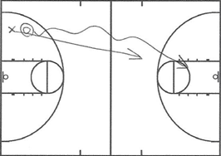

Block Finishing 1v1 (@PositionlessBb)

1’s and 2’s to 15

The coach can throw the ball to either player and play is live (can be one shot or until a score/defense rebounds). A stop is worth one point.

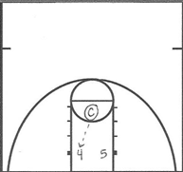

## 1v1 Dribble to Half Then Attack (@basket_ADN)

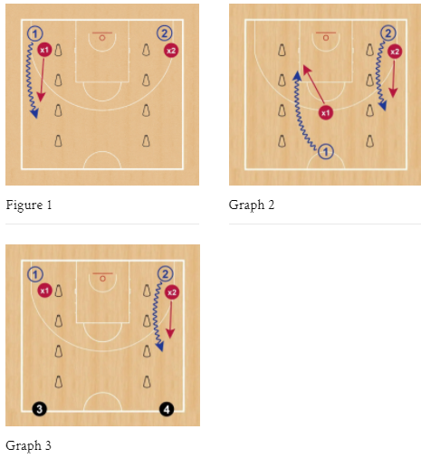

## Full Court 1v1 (@basket_ADN)

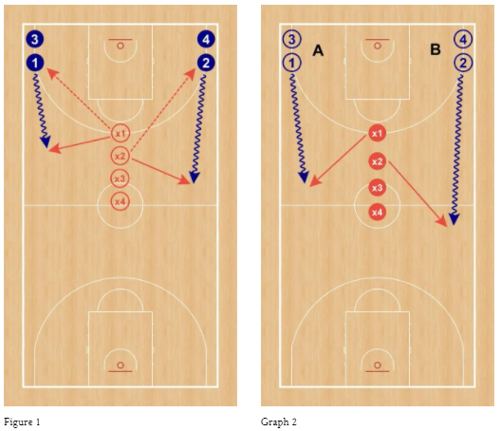

## 4v4 Line Advantage (@basket_ADN)

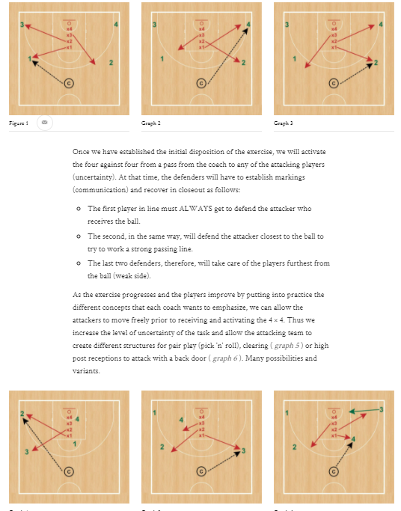

## 3v3 Track Race (@basket_ADN)

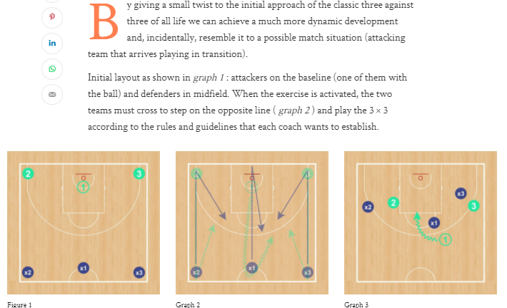

<https://youtu.be/QUphdGmGkts>

## 1v1 Full-Court Russell Westbrook Triangle (Gerald Hiller)

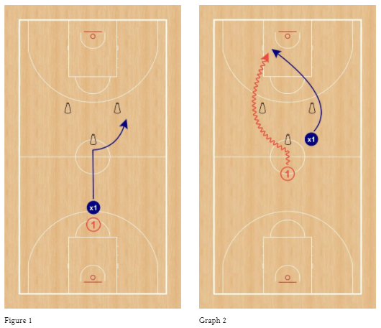

## 1v1 “Off the Hip” (Game Time Elite Training)

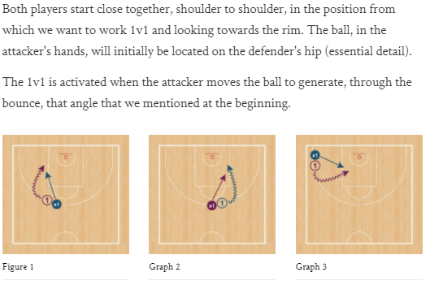

## 1v1 Sprinter’s Stance (@basket_ADN)

https://www.youtube.com/watch?v=GDSk5dVISuQ

## 1v1 Handout (@basket_ADN)

https://www.youtube.com/watch?v=mo5RlMe95y8

## 3 Passes + Closeout (@basket_ADN)

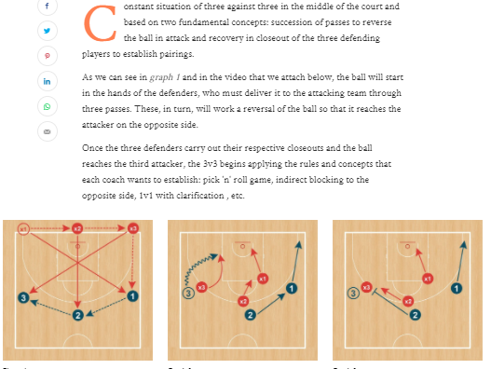

<https://youtu.be/EUtko7u_Puc>

## 3v3 w/ Advantage (@mshaughnessy11)

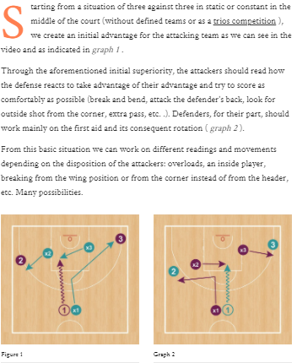

## Random 1v1 (Sergio Lopez Sanchez)

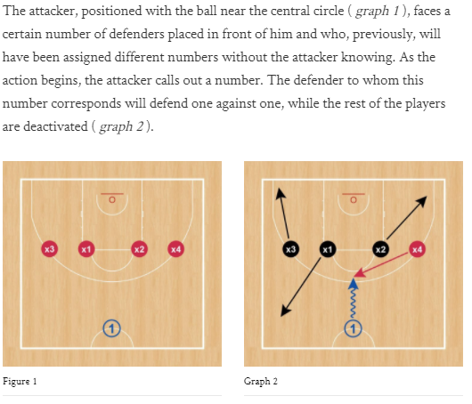

## 2v2 Variations (Sergio Lopez)

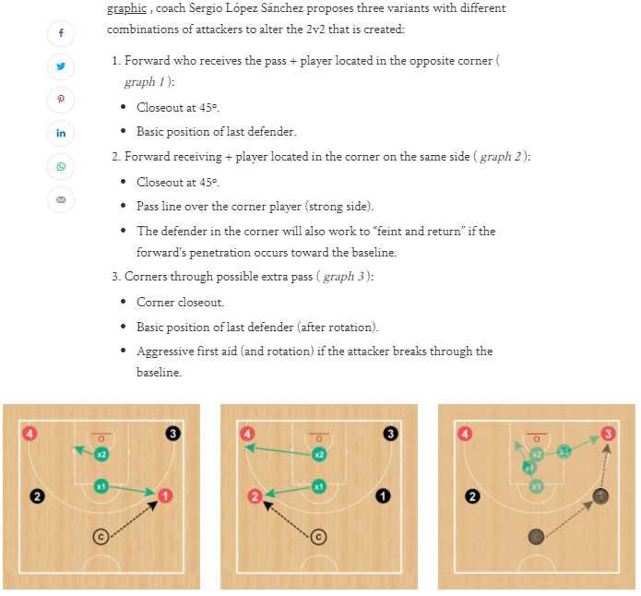

## 1v1 “Cat & Mouse” (Gerard Hillier)

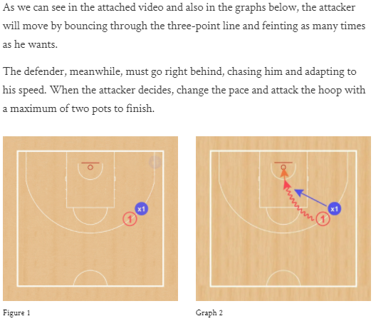

## 1v1 Perimeter Attack (Comite Tecnic FCBQ)

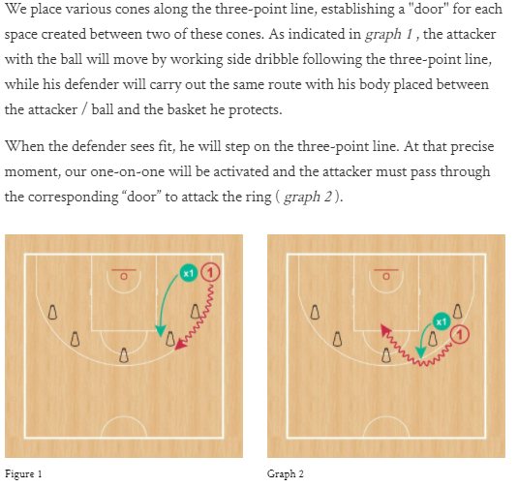

## 1v1 Touch Cone Attack (Gerard Hillier)

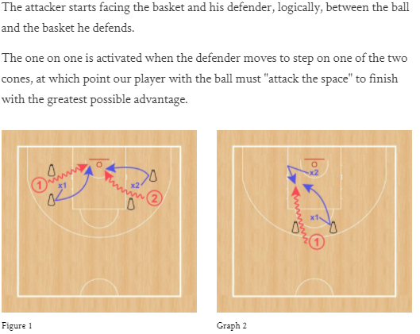

## 3v2 From a Closeout (Joventut de Badalona)

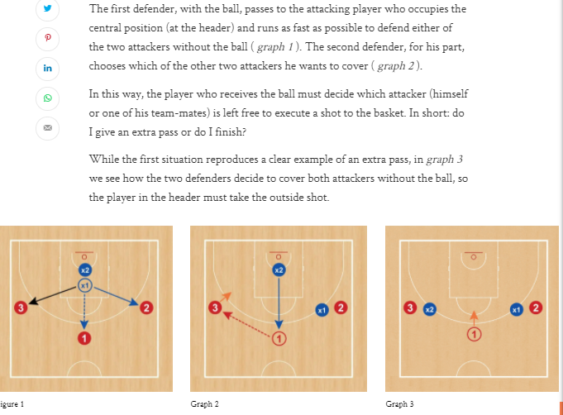

## 1v1 From a Closeout (@mshaughnessy11)

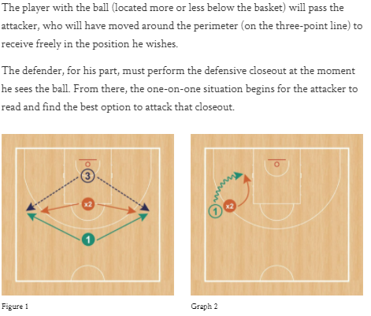

## 1v1 Inside/Out (Game Time Elite Training)

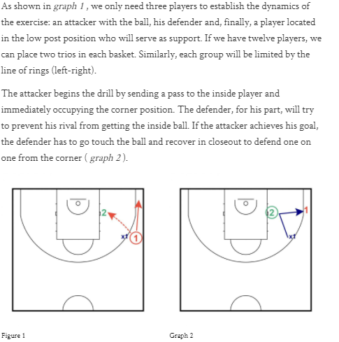

<https://youtu.be/F69G54skXfY>

## 1v2 Basket Attack (Angel Tripiana)

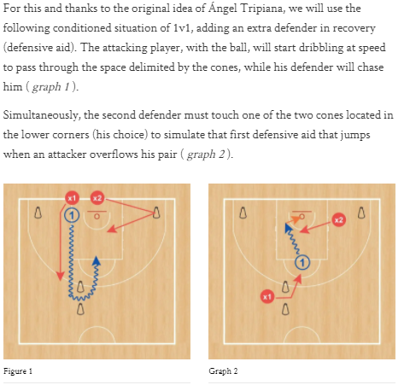

## 1v1 Full Court Attack (@basket_ADN)

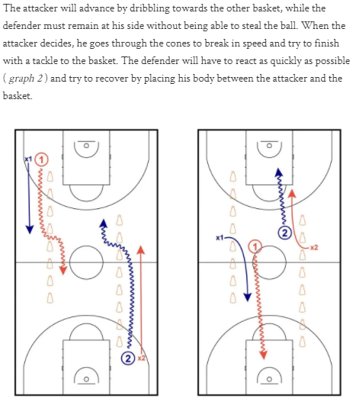

## 2v2 Basket Attack (Ziya Hepbir)

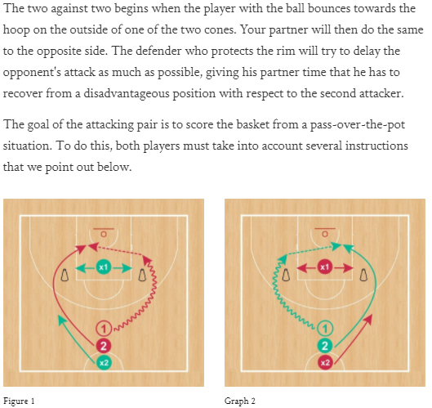

## 1v2 into 2v1 (@basket_ADN)

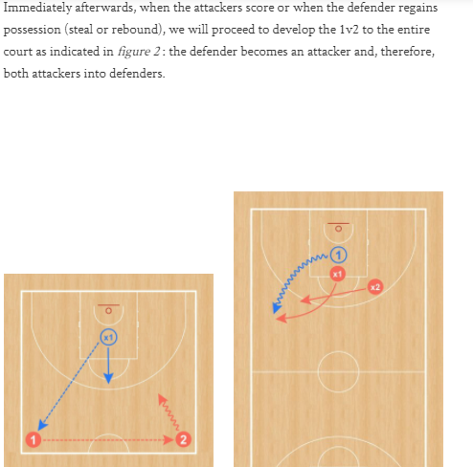

## 1v2 Advantage Finishing (@basket_ADN)

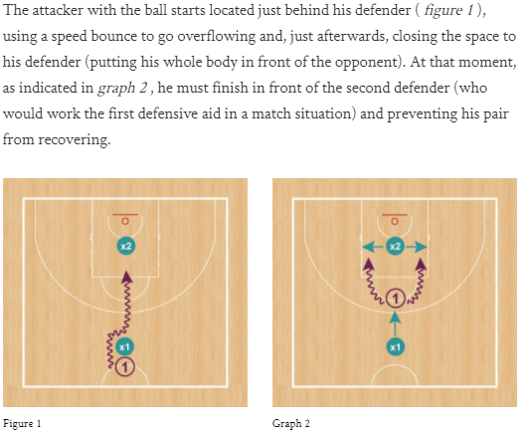

https://www.youtube.com/watch?v=FhJT2ncmXwY&feature=youtu.be

## 1v1 “Hot Potato” (@basket_ADN)

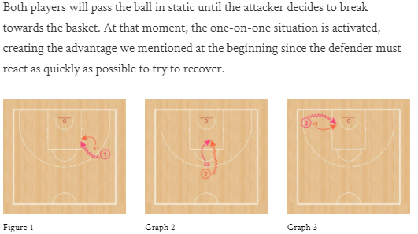

## “Hot Potato” 2v1 (Adrian Murciano)

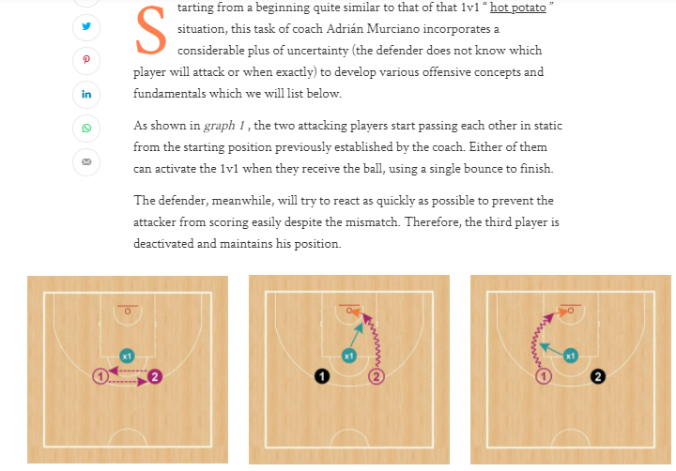

## 1v1 Who Receives Defends (@basket_ADN)

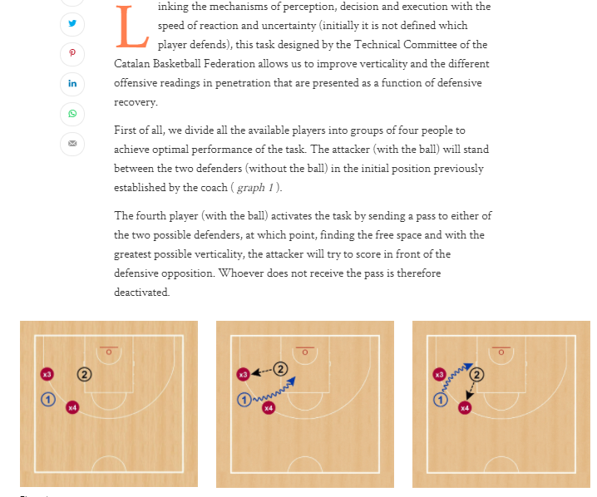

## Five Plus One (Fran Francilla)

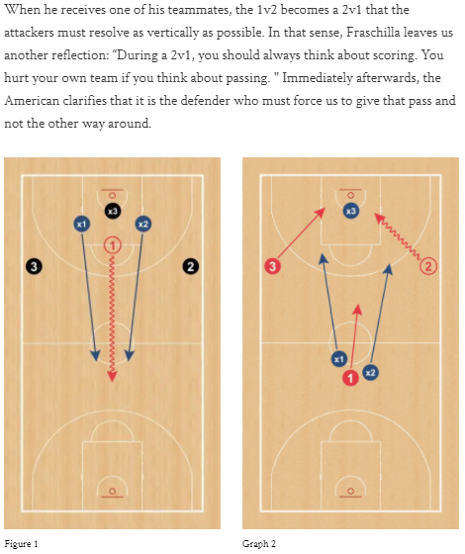

<https://youtu.be/vwNPxpptjRI>

## 1v1 Interpret the Advantage (@basket_ADN)

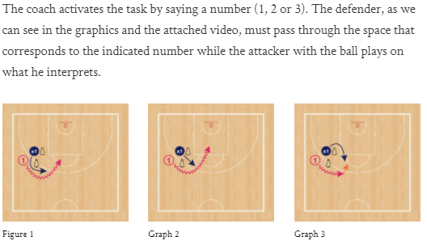

## 1v1 Triangle Attack (Game Time Elite Training)

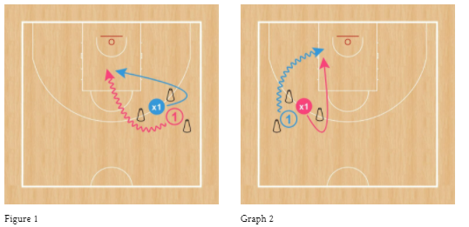

## 1v1 “Back-to-Back” (Comite Tecnic FCBQ)

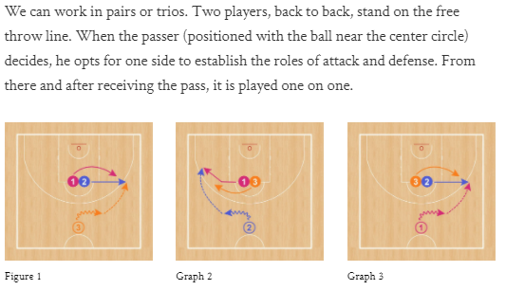

<https://youtu.be/bEU0HHXnwK8>

## “Blind Cut” 1v1 (Alex Sarama)

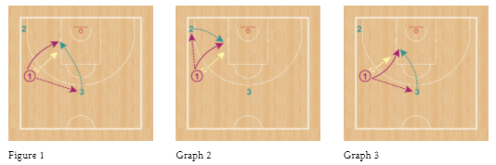

Defense starts with their back to the offense

## 3v0 into 1v1 “One More” (Adrian Murciano)

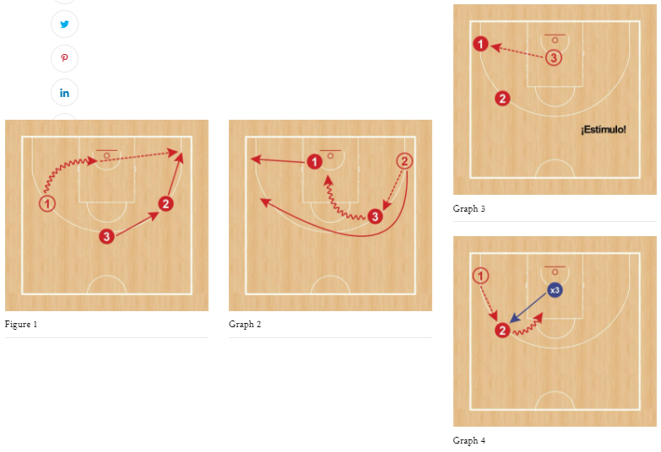

## 1v1 “Fosters” (Cedarville WBB)

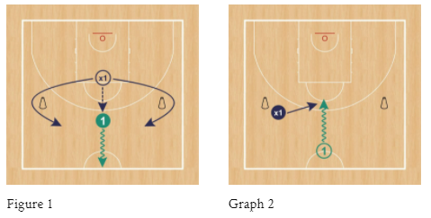

## 1v1 Cycle Pass (Eduardo Burgos)

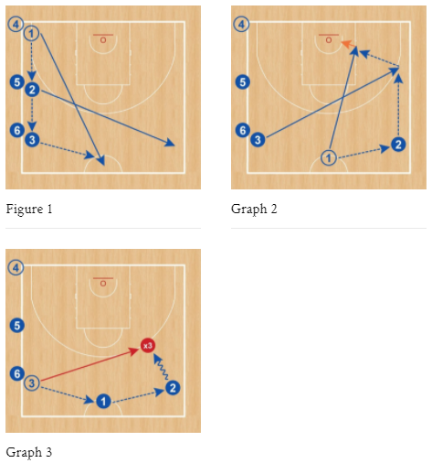

## 1v1 Read & React Around Cones (@basket_ADN)

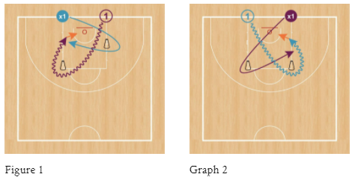

## 3v1 Double Pass (@basket_ADN)

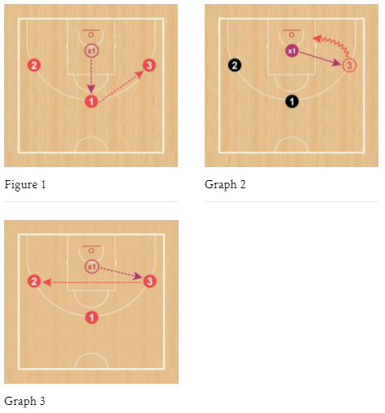

## 1v1 Around Cones (@basket_ADN)

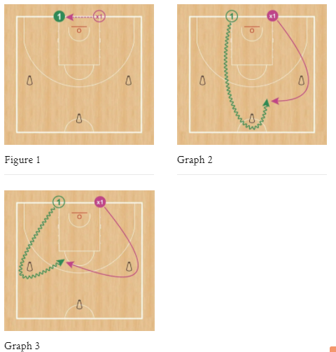

## 1v1 Chair Attack (@basket_ADN)

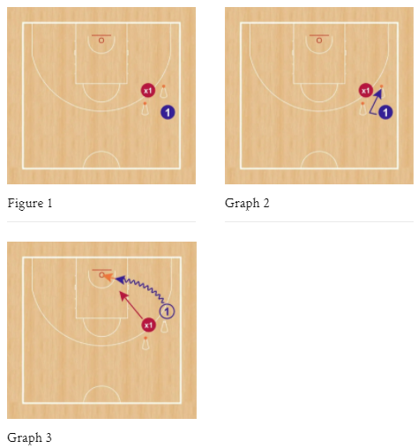

Note: in the picture above, the cones are chairs with balls on them

Rules: prior to the offense picking up ball, the defense must mirror the side-to-side movements of the offense. The offense activates the drive by picking up a ball.

## 1v2 Receive & Attack (@basket_ADN)

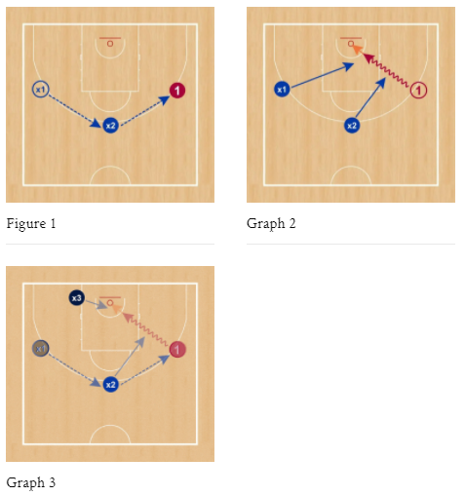

Variation: Uncertainty 🡪 Three players pass to each other uninterrupted passes until the coach’s signal (auditory or visual); whoever has the ball attacks and the other two players defend

## 2v2 Rugby (@brianmccormick)

1’s, 2’s and 3’s to 10

Full court 2v2 (shrink the width) and the defense must trap. The offensive player with the ball can dribble (forward/backward) but can only pass backwards. Once the ball gets over the half court line, play 2v2.

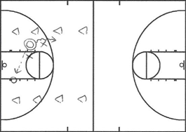

https://www.youtube.com/watch?v=E5dqoXeWUk8

## Dribble Knockout (@Nick_Sciria)

Create a playing space with cones. Players try to dribble their own ball while forcing the other players to lose possession of their ball. Shrink the space as players are eliminated. Can be played with only weak-hand dribbling allowed or both hands.

## 4v3 (4) Passing Warmup

▫️Offense in a box

▫️:45 on the clock

▫️4 v 3 for the 1st :20

▫️4 v 4 the last :25

▫️Offense is allowed 1 step any direction off their start spot

▫️Defense gets 1 point = tips, steals, force O to catch off spot

## 12-Second Drill (Xavier MBB)

🔘4️⃣ Seconds on a Pivot.

🔘4️⃣ Seconds Live Dribble.

🔘4️⃣ Seconds on a Pivot.

1 of my favorite drills to teach kids to be strong & poised w/ the 🏀! 1 thing we did was to add a vision component. We added a coach that the offense had to see (raising a🏀 or✊). If you notice, #13 has his eyes down under pressure (pivoting &⛹️‍♂️) which is very common.

* Tell them to avoid spinning in circles. That's an important coaching point when handling vs pressure. I prefer them to move as little as possible.

## Lane 1v1 for Ball Handling (@Nick_Sciria)

The offensive player tries to control their dribble as long as possible against their defender while staying inside the lane. Play best of five rounds, timed.

## 1v2/2v3 for Ball Handling/Passing against Traps (@Nick_Sciria)

Create a playing space with cones. The player (or team) on offense tries to maintain possession for as long as possible. For 1v2, you can have a set rotation or the player who gets possession of the ball can continue right away every time. The player (or team) to accumulate the most time after so many possessions wins.

## 4v5 Complete Ten Passes (David Richmond)

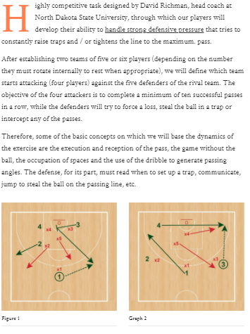

<https://youtu.be/amc28rqQpjs>

## 1v2/2v3 Ball Handling/Passing against Traps (@Nick_Sciria)

Shrink the width. The player/team starts on the baseline with the ball and then tries to advance the ball past half court in ten seconds of less. 1’s (possessing the ball through half court) and 2’s (possessing the ball through half court in the middle third) to 5.

## Gael 2v2/3v3/4v4/4v5/5v5 (@brianmccormick)

No dribbling or shooting (player with the ball is only allowed to pivot and pass). Offense tries to complete seven consecutive passes for a point (play to four points). On-ball defenders are only allowed to trace the ball to get deflections (they aren’t allowed to take the ball from the offensive player). On turnovers, new offense can begin passing right away. The playing space depends on the amount of players.

https://www.youtube.com/watch?v=6jULA7LAlC4

## 4v4/5v5 Ultimate Basketball (@Kirby_Schepp)

No dribbling or shooting (player with the ball is only allowed to pivot). Offense tries to maintain possession until getting the ball into the endzone. Play to five scores. On-ball defenders are only allowed to trace the ball to get deflections (they aren’t allowed to take the ball from the offensive player). On turnovers, new offense can begin passing right away. The space depends on the amount of players.

https://youtu.be/RygNF4LakhI?t=1785

## Six Spot Shooting (@Nick_Sciria)

Shooter shoots for two straight minutes. Shooting spots are the two corners, the two wings and the two slots. Shoot at a spot and then rotate to the next spot. Count the number of made shots for score.

## Two Makes In A Row Shooting (@Nick_Sciria)

Shooter shoots for two straight minutes. Shooting spots are the two corners, the two wings and the two slots. The shooter must make two shots in a row in order to rotate to the next spot. Count the total number of shooting spots completed for score.

## Two Misses In A Row Shooting (@Nick_Sciria)

Shooter shoots for two straight minutes. Shooting spots are the two corners, the two wings and the two slots. Shoot at a spot until two shots are missed in a row, then rotate (can only be at a spot one time in the two minutes). Count the number of made shots for score.

## Corner, Opposite Corner, Lift, Drift Shooting (@Gabe_MaciasGTET)

Shooter shoots for two straight minutes. Shoot from the corner, opposite corner, lift to wing, drift to corner continuously until time is up. Count the number of made shots for score.

# Shooting Games (No Defense)

## 3v3 Full-Court-Trios (@basket_ADN)

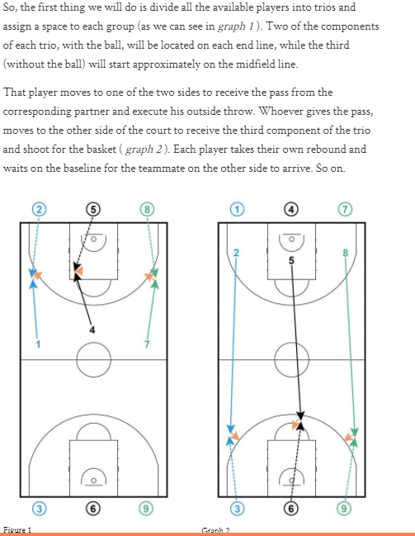

## Full Court Diagonal (2 teams) (@basket_ADN)

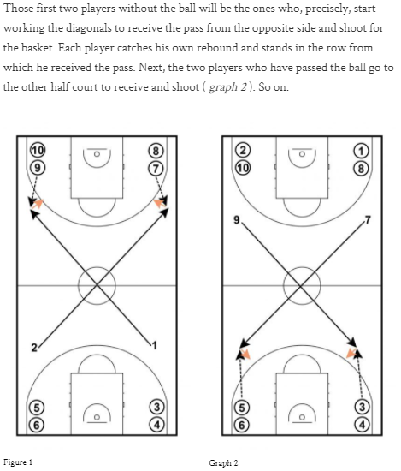

## Zach LaVine (Drew Hanlen)

Just finished working out Zach LaVine. Here's a shooting drill we did to warm up. Every third shot is a "money ball." If you miss the money ball, you move on to the next spot. 5 spots. Goal is 50+. Zach just got 84 which means he made 28/33 money balls

## Around the World (Drew Hanlen)

• 10 spots, 4 shots at each

• 4-4 = skip a spot

• 3-4 = next spot

• 2-4 = stay

• 1-4 = back a spot

• 0-4 = start over

## Moneyball Shooting (Drew Hanlen)

Players partner up, each partner shoots 4 shots, then switch.

Shot 1: Catch + Shoot 3 "Moneyball" = +3 if made

Shot 2: Catch/Shoot 3 = +1 if made

Shot 3: Dribble Jumper = +1 if made

Shot 4: Catch/Shoot 3 = +1 if made

1st team to 25 pts & at half court wins

## Louisville Shooting Challenge (@basket_ADN)

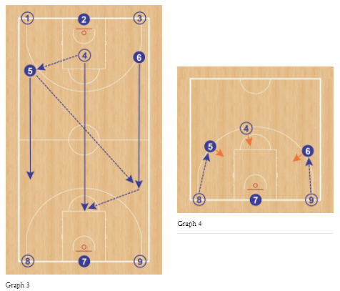

## 3-2-1 Perfect Drill (Chris Payne)

“3-2-1 Perfect” drill, which Payne purposefully picked as one of the last drills to simulate end-of-game fatigue. Make three shots in a row from five different spots around the halfcourt. Then, come back and make two in a row at the same five spots in reverse order. Then, finish with a perfect five-for-five at one spot. The drill doesn’t end until the player makes the five straight.

## Olympic Shooting (Alex Sarama)

➡️ 3 shooters, 2 basketballs per group.

➡️ Pass to the same teammate each time.

➡️ Relocate to a new spot after each pass.

✅ Random

✅ Game-like

# Overall Offense Games

Here are some games that just work on overall offense:

## “The Kinder Surprise” (Alex Sarama)

🏀 Offensive player stands blind. They do not know what surprise is waiting for them!

🧠 Live on the turn around. Must immediately scan and look for a solution.

💡Use as a start before transition trips. Can do in any format (2v2 up to 5v5).

There is also a version where the dribbler has their eyes closed and opens them on the coach's command. Must find their defender and read the help.

## “Change” Drill (@fra_reds)

💡 Fun and simple SSG for early in practice.

🗣 Coach randomly calls “Change”. This cues the teams to change baskets, leading to numerous situations emerging.

## “Dagger” ORB 3v2 (@CoachZHoops)

A "dagger" is an O reb & kick out for 3.💡came from an Elon MB practice a few years ago- pause for rules.

Teams of three – 3 offense, 2 defense

5 possessions on offense then switch

Track # of successful possessions (e.g. 2/5 or 3/5)

Allow offensive rebound then defend

* 2 options – quick put back or kick out for 3

Offense can NEVER hold the ball – quick reads

* Yell “1 more” if the quick swing is open

Offense must yell “Dagger” on 3 for it to count

Rotation:

* Offense: rebounder to wing to top
* Defense” post to perimeter to out

Optional: 3-pass limit

## 6v6 No Dribble Zone O (Andrea Trinchieri)

"It's a stupid little game, but they have to pass the ball, they have to play in space and pass in holes - it will help your zone offence."

## 5v5 Half Court/Full Court Perfect Offense (@Nick_Sciria)

1’s, 2’s and 3’s to 10

Teams can only score on offense. If the defense gets a stop, they go to offense. If the offense messes up (choose specific teaching points to look for), they go to defense.

If playing in the full court, the coach can whistle a turnover for the offense if they mess us. The offense would then drop the ball and get back on defense.

## 3v3v3/4v4v4/5v5v5 Continuous Full Court (@Nick_Sciria)

1’s, 2’s and 3’s to 10

The offense plays a half-court possession against the defense. If the offense scores, they take it out of the net and go the other way while the defense presses. Once the ball crosses the half-court line, the third team defends and play continues. If the offense failed to score on the initial possession, the other team would bring the ball up the court against the team waiting on the other side.

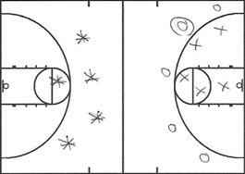

## Walsh 5v5 (@CoachBobWalsh)

Regular basketball scoring

Start with a live game tied at 70 with 2:30 left on the clock. Once a team reaches 76, the clock starts.

## 5v5 with Any Start, Three/Four Trips (@r_b_j_c)

1’s, 2’s and 3’s to 10

This can be combined with any start to provide stoppages in play for teaching moments. Three trips means here, down and back. Four trips means down, back, down and back.

# Overall Defense Games

Here are some games that particularly work on defense:

## Accountability Basketball 5v5

5v5, the first thing you have to do is execute our offense and get a great shot. If you do that, you go to the next phase of the game and play in transition. Execute transition D properly, communicate, find shooters, everything has to be perfect. Now you defend half court. If you guard correctly and you jump to the ball and you do it perfectly. If you do all that and you box out and you secure the ball, you get one point.

## 3v3v3/4v4v4/5v5v5 Full Court Football (@RadiusAthletics)

The defense must get four stops in a row. If the offense scores, the next possession becomes “first down” again. The offensive teams switch after two trips (down and back). The team that gets four stops in a row in the fewest number of possessions wins. You can also make a rule that an offensive rebound automatically resets the downs.

## Kill Drill

3 Stops = 1 kill. 3 teams of 5. Offense rotates in. If you get a stop you stay on. Coach offense (leave defense alone) and call ticky tacky fouls.

Texas Tech MBB “Kill Drill”

• 5 players on defense; they have to play, without substitutions, 90 seconds or three defensive possessions without giving up a basket

• If opposing team scores the clock starts over

Side note: Coaches have their own standards of defensive stops

## 3v3 Closeouts (Tony Bennett)

the three-on-three closeout drill. Three offensive players scatter around the perimeter, one in each corner and another at the top of the key. Three defenders cluster together underneath the basket. A coach throws the ball to an offensive player chosen at random, and from there, they play three-on-three. Maybe it doesn’t sound like much. But when a player is sprinting from underneath the basket to where a dead-eye shooter is standing, or trying to cover the gap on a floor that can feel like acres of space, it’s easy to get beat. “You have to be in a dead sprint closing out if you want any chance,” says Nolte. “It exaggerates the amount of space you have to cover.” And when the offense scores, the defense stays on. Sometimes for possession after possession, until they’re begging for a lucky miss, a sloppy pass, any kind of break. “When I first got there, I would just pray — pray — that the offense would miss,” says Anderson, now with the Philadelphia 76ers. “By the time I left, though, it was one of my favorite drills.”

## Decibel Level Game (Coach Yelich)

Decibel level app: have coach stand at top of key or under basket. Shell drill. Team with lower decibel number loses.

## Defensive Bingo (Coach Yelich)

Coach Yaklich Texas Talk Defensive Language - Defensive Bingo

# Situation-specific Games

## Simulated shortened game

Simulated game, four quarters, minutes between 1 and 3, players coach and substitute themselves. See who can manage the clock best.

## Timeout notecard tests

Bob Knight loved to do this. Simulated timeout, draw up a play, then test players on what the drawn-up play was by having them write it out on notecards. Give them grades on their retention of the play. This will help you understand who can execute late in games and who cannot.

## “Mind Bomb” Games

Introduce a “mind bomb” set/scenario at the beginning of practice, then sprinkle it into practice like a special teams field goal unit.